

PX505 Mid-Report

eTex: Electrical signal conversion of a triboelectric fabrics into a sound or light signal

Azmi Abbessi | Sébastien Barbero | Félix Roux

Table des matières

Project Idea 2

Detailed Project Development Plan 3

Analog and ADC 3

Embedded Algorithmic 3

Communication 4

Side Tasks 4

Project Schedule 5

Individual Tasks Partition 6

Organisation 6

Communication 7

Milestones and Risk Analysis 8

Insights on Societal Changes 10

Complete Purchase List 11

# Project Idea

The field of wearable intelligent textiles is an emergent, promising market. This discipline aims to improve the usability and the number of uses of clothes, simply reinventing what a piece of textile really is. A precise use of this technology takes advantage of movement, and other phenomenons such as friction, to generate electricity.

GammaO is working in the field of triboelectricity applied to the textile industry. They create high-tech and high-quality clothes, that are built to harvest energy generated by athletes’ efforts. Then, emerged the idea of applying this technology to the event and showbusiness market, as follow :

1. Triboelectric electrodes made by the company GammaO are placed on a surface of clothing or furnishing textiles, used by an artist or performer. These persons, by performing with the equipped textile, would activate the electrodes by friction, thus generating an electric signal, that could be then used and interpreted.
2. The generated signal would be processed and/or acquired by a digital electronic card. This chip would embed an algorithm, that could interpret different components of the signal, and generate an artistically usable output.
3. The outputted signal, processed according to the standard communication protocols between electronic instruments, controllers, sequencers, and music softwares, would then be used to control sound triggers, light events, scene changes… All according to the performance of the persons, while being very stealthy and non-intrusive to the performers.

In other terms, we could imagine a jacket, equipped with GammaO electrodes, built for a dance performance or a ballet. As the dancer would simply dance as usual, the movements and frictions generated would be picked up, interpreted, and transmitted to a control desk, which could trigger light changes as the dance would get more and more intense.

# Detailed Project Development Plan

This project, for an easier management, and in conjunction with the company’s responsible, Pascal Weber, has been separated in 3 distinct parts, all with different end goals.

## Analog and ADC

As this project includes the use of pretty experimental sensors, as well as a potentially noisy and harsh environment (*f.e.* in the case of sweat, a lot of friction would be lost), we feel the need to dedicate a whole part of the project to the acquisition of the signal.

There will potentially be the need to heavily filter the input signal, as the sensors seems very sensible to noise, and especially 50Hz. We can also make the assumption that a lot of the signal could be very useless to the artistic interpretation of the performance, and could thus be removed to allow for a better interpretation. We can also question the use of vibration-sensitive sensors in an environment where there is potentially very loud music, and that will also need to be explored.

We will also need a well dimensioned ADC, as the intensity of the signal out of the sensors is pretty low, according to our first tests. We will also be constrained in the number of cells we can put on, depending on the number of ADCs our card will have.

## Embedded Algorithmic

This is the part that could be the most exciting, where we could innovate the most. We’re going to try to convert signals that are collected from a performer, and we’d like to be able to capture the whole dimension of the performance : if there is a long, intentional movement, we will need to be able to capture it properly, in order for the triggered event to react accordingly. The same goes for short and abrupt movements, or even hits if the sensor allows it.

We will then need to convert all of these parameters in MIDI messages, which is an international and industry standard for music and performance related tools’ communication.

There could also be a tiny bit of programming that would need to be done in order to develop a driver if the need appears, but as every MIDI message is usually programmable and fully flexible, this need will probably not arise.

## Communication

If we were to develop a textile that would be meant to stay put (*f.e.* a carpet, rug, or table cloth), we could use a simple MIDI DIM5 connection to link the device to the rest of the MIDI ecosystem : a cable would not be limiting for the device, not for the usage of it in a performance.

However, the same cannot be said in the case of a mobile, or even really portable device (*f.e.* a jacket, or guitar strap). A cable would be too daunting to deal with, and the need for a wireless connection arises. We already identified ready-to-use solutions on the market, but it could be interesting (if the time allows us) to try to develop our own low-latency wireless system. There would also be a way bigger constraint on size, weigh, and battery life and autonomy, in such a use case.

We will investigate if the effort of developing a new device can be worth it : if we consider we cannot do better, cheaper and/or more reliable than existing solutions, we will very likely not use a home-made tool to wirelessly transfer data.

## Side Tasks

To all that we can do, we can include an actual demonstrator to emphasize the potential of the technology. We can probably help with the design of a demo for a potential artist, and propose a demonstration of the tool with an actual performance.

However, that needs to be discussed, as the implication of a third-party could take a lot of time for a result that could be mitigated.

# Project Schedule

Our main method being a V cycle, we can divide our project in blocks

which are the following: Research and Specification, General design, Detailed design, Achievement, Testing and Validation

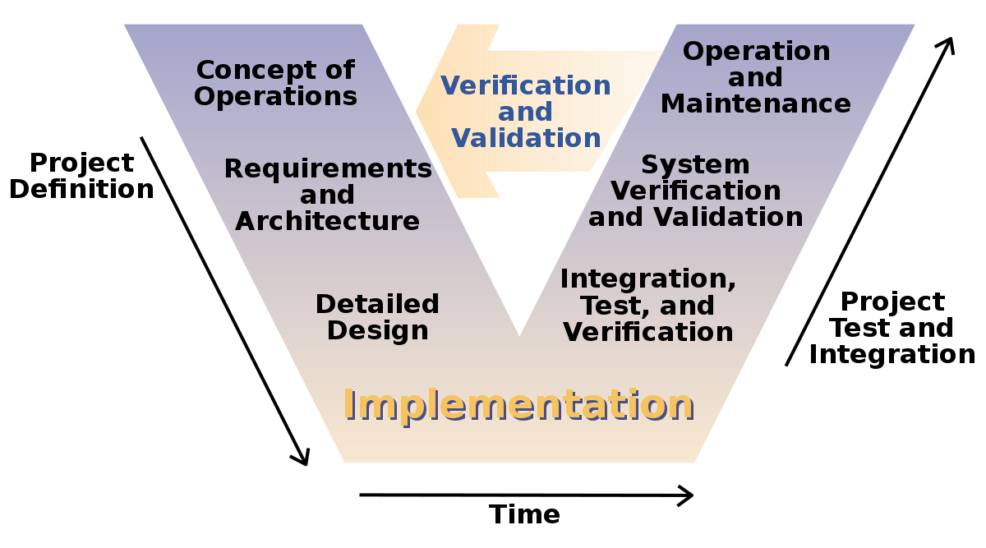

# 

# 

# 

We can therefore imagine a schedule of the following form :



# Individual Tasks Partition

The project team is made up of a project manager and 3 students from the Esisar – Grenoble INP.

The project manager is **Pascal Weber, CEO** of GammaO.

The student team consists of 3 students:

* **Sébastien Barbero,** apprentice student in Electronics and Computer Systems (EIS).
* **Félix Roux,** student in Electronics and Computer Systems (EIS).
* **Azmi Abbessi,** international student in Master M2 in embedded systems security (Mistre program).

## Organisation

| Tasks\Team | Félix | Azmi | Sébastien |
| --- | --- | --- | --- |
| Research and Specification | X | X | X |
| General and Detailed design | X | X | X |
| Software development | X | X | X |
| Hardware development |  |  | X |
| signal processing | X | X | X |
| Testing and Validation | X | X | X |
| Demonstration and report writing | X | X | X |

## Communication

To assure the smooth running of the work within the deadlines, it is essential to put in place communication rules early enough to make the task easier. The most formal way proposed, giving traceability throughout the project, is here the communication by email using the specific email provided by the school.

However, it can be a bit daunting and irresponsive at times. Therefore, it is also possible to exchange informal messages in a faster and more instantaneous way thanks to WhatsApp. The team will also hold scheduled face-to-face meetings, on a base of once every two to three weeks. In the event of an emergency, the team can also contact M. Weber by telephone.

# 

# Milestones and Risk Analysis

We can identify a few major milestones, and overall goals to the project :

1. A clear acquisition of the provided sensors, and a qualification of the signal. This would allow for a good understanding of the phenomenon, as well as a starting point for signal interpretation.

Since we want to use these signals in expressive ways, we’ll have to pay a particular attention on how we will define the “qualities” of the signal : length, intention, intensity (that can evolve over time)…

1. A working MIDI controller, based on the characteristics of the signal we will want to use. This will allow us to try to trigger events on MIDI-based softwares as a proof of feasibility.

A simple proof of the usability with such a device would be to be able to simply trigger various midi event on a compatible software, such as Ableton Live.

1. The linkage of the two parts, a signal captured by the sensor, triggering an event on such a software.

This can be tested by assembling the two latest tests, in order to trigger midi events on Ableton by interacting with the sensors in a controlled environment.

1. A wireless connection, at least through the use of a market-ready solution, to test the limits of such devices and allow for first prototypes development and tests.

We already identified and validated with GammaO the choice of such devices : we will us a pair of MD1 MIDI Wireless System, by XVive.

Now we can talk about the secondary and optional goals :

1. A wireless MIDI connection through a home-brew wireless system. As the Vive product can be faulty, or not integrated enough with the solution, we can try to realize a wireless low-latency communication between the device and Ableton, if time allows us to do so.
2. The realization of a demonstrator and/or prototype, with the end goal being a representation heavily using the concept. We talked extensively about a jacket that could be equipped with the product : this is to be discussed with the company, but the goal could be reached even by doing such a performance with a “monster” (a textile term designating a functional but non-esthetic piece of clothing or textile).
3. A calibration/setup function through MIDI In : as the sensors will maybe be used on different parts of the body, or used in different ways, we could imagine the way the signals are interpreted could be controlled by the MIDI-compatible software. As MIDI is bi-directional, we could send MIDI data to the product, in order for it to react differently to different inputs.

As the project is pretty exploratory, and the company doesn’t focus heavily on that direction and product, there are few risks associated with the project. We can although mention a few risks :

* The unfeasibility of the project due to a technical limitation. This could happen if the sensor would be inadequate for that application, or if the communication cannot be established between the product and the software. In that case, we would need to find a way to redefine the objectives with the company, while still delivering a work that could be used in the context of the company.
* The rise of a new Covid (or similar illness) wave. This would be a heavy break to the project, as it could put a limit on our capacity to develop the electronics. That, however, could be managed through sanitary precautions and telework, and a potential review of the objectives.
* The withdrawal of the company in the project. This is again highly unlikely due to its investment, and we would find either another project or finish the project without the company, working on the parts on which we could be autonomous.
* A delay in the delivery of components, or a complete shortage : In this case, we could only deliver software elements of the project to the company, and/or lower our expectations in terms of hardware.

# Insights on Societal Changes

The direct impact that this project will have on society is a change in the way the artists can perform their show. Imagine this : the performer, by simply rubbing their hand against their clothe, will be able to change the ambient sound, light, or trigger light effects, fireworks, etc. This will make shows even more incredible, looking as if magic was at use.

But it is also a way to promote triboelectricity, as it is an energy harvesting technology. Private investors might see interest in this technology, which might help it spreads and grows. This will result in a good environmental impact since the expansion of energy harvesting means less use of the energy production means currently at use and known for their big and negative environmental impact.

Solutions using these products generates little voltage and far too little current to be of any harm to people using it or getting in contact with someone equipped with it. However, they are an interesting field of research, and experimenting with them might lead to new sources of renewable energy !

Regarding environmental impact, as these clothes integrate electronic, it raises the questions repairability, reusability and of the end of life of the products. How can they be maintainable, recyclable ?

# Complete Purchase List

* 2x Xvive MD1 devices
* *To be determined*